**Measuring the Mass of Ruler**

**using Moments**

**11 /22 /2018**

**Ruiyan Maggie Huang**

**Physics 3**

**Abstract**

Using the principle of moments, the mass of a ruler is measured by changing the position of another mass and thus the pivot. The resulting value is 55.12 $±$ 0.05, which is almost consistent with the theoretical value 55.66 $±$ 0.01g measured by the electronic scale, indicating it follows the principle of moments.

# Background and Introduction

### Theoretical background

When a force is applies to an object with a fixed point, the object will rotate around that fixed point known as pivot. The product of the magnitude of the force and its arm (the distance from pivot to the line of action of the force) is defined as moment.

The principle of moments state that a lever is balanced when the sum of clockwise moment equals the sum of anticlockwise moment, which can be expressed as:

$$F_{1}D_{1}=F_{2}D_{2}$$

In the formula, $F_{1}$ is the force acting on the lever with clockwise effect; $D_{1}$ is the distance from the pivot to the line of $F_{1}$; $F_{2}$ is the force acting on the lever with anticlockwise effect; $D_{2}$ is the distance from the pivot to the line of $F_{2}$;

Deriving from this formula, we can also get:

$$F_{2}=\frac{F_{1}D_{1}}{D_{2}}$$

Thus, knowing the value of the other three variables, we can calculate the value of $F_{1}$.

If we divide both sides of the equation by g the gravitational field, we get:

$$m_{2}g=\frac{m_{1}⋅g⋅D_{1}}{D_{2}}$$

$$m_{2}=\frac{m_{1}⋅D_{1}}{D_{2}}$$

### Objectives

The aim of this experiment is to measure the mass of a given ruler using the principle of moments, and then compare the experimental result with the theoretical value. We put the same mass on different positions of the ruler, and thus adjust the position of the pivot to keep the lever balanced.

We hypothesized that by changing the positions of the mass, in order to keep the equilibrium of the ruler, the pivot has to change according to the principle of moments, in consistence with the principle of moments. We will find the mass of the ruler using data derived from the position of mass and pivot.

# Materials and Methods

### Materials

A meter ruler, a set of 50g masses, a binder clip, a paper clip (wire), and an electronic scale.

### Variables

Independent variable: the position of the mass

Dependent variable: the position of the pivot (the binder clip)

Controlled variables: the mass m1, the mass of the ruler, m2 the center of mass of the ruler.

The controlled variable will be controlled by using the same mass and the same ruler throughout the experiment.

### Procedure

1. Gather all the materials.
2. Put the two tails off the binder clip and bend the paper clip straight to a wire. Insert the wire vertically into one of the two holes between the binder clip and make sure it is fixed.
3. Put the ruler on the binder clip, adjust until it balances, and record the precise position of the pivot, which should be around 50cm, and that is the position of the ruler’s center of mass.
4. Pile two 50g masses on the 5cm mark of the ruler. Adjust the pivot until the ruler balances again. Record the position of the pivot.
5. Change the position of the mass in graduation of 5 cm a time from 5cm to 40cm, and record each position of pivot, respectively.
6. Calculate the mass of the ruler using data collected in the experiment.
7. Measure the mass of the ruler using the electronic scale and compare the experimental result and the theoretical value.

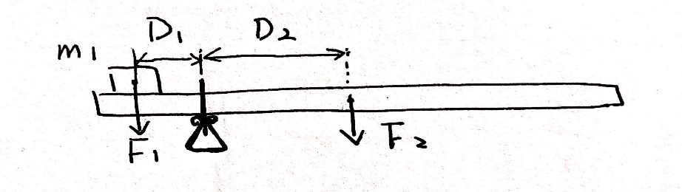

Figure 1. the apparatus

# Data and Calculations

### Raw data

|  |  |  |  |  |
| --- | --- | --- | --- | --- |
| **trails** | **m1 (g)** | **position of mass (cm)** | **position of pivot (cm)** | **uncertainty** |
| **1** | 100 | 5.00 | 20.70 | 0.25 |
| **2** | 100 | 10.00 | 23.80 | 0.25 |
| **3** | 100 | 15.00 | 27.20 | 0.25 |
| **4** | 100 | 20.00 | 30.45 | 0.25 |
| **5** | 100 | 25.00 | 33.55 | 0.25 |
| **6** | 100 | 30.00 | 36.80 | 0.25 |
| **7** | 100 | 35.00 | 40.00 | 0.25 |
| **8** | 100 | 40.00 | 43.25 | 0.25 |

Table 1. the raw data from experiment

In Table 1, all the raw data are given. m1 is the mass, which is 100g; position of mass is where the mass is on the ruler; position of pivot is where the binder clip is according to the numbers on the ruler. The smallest division of the ruler is 0.5cm, so the uncertainty should be 0.25cm, which is half of the smallest division.

Also, the center of mass of the ruler is 50.15 $±$ 0.25, and the theoretical value of mass of ruler is 55.66 $±$ 0.01 measured by using the electronic scale.

### Processed data

|  |  |  |  |  |
| --- | --- | --- | --- | --- |
| **trials** | **m1 (g)** | **D2 （cm）** | **D1 （cm）** | **uncertainty for ruler （cm）** |
| **1** | 100 | 29.5 | 15.7 | 0.5 |
| **2** | 100 | 26.4 | 13.8 | 0.5 |
| **3** | 100 | 23.0 | 12.2 | 0.5 |
| **4** | 100 | 19.7 | 10.5 | 0.5 |
| **5** | 100 | 16.6 | 8.6 | 0.5 |
| **6** | 100 | 13.4 | 6.8 | 0.5 |
| **7** | 100 | 10.2 | 5.0 | 0.5 |
| **8** | 100 | 6.9 | 3.3 | 0.5 |

Table 2. processed data from the experiment

Figure 2. The relationship between D1 and D2

As the graph shows, there is an approximately proportional relationship between D1 and D2. The gradient of this graph is then D2/D1, which is expected to be constant because

$$\frac{D_{2}}{D_{1}}=\frac{m_{1}}{m_{2}}$$

By using the gradient in Figure 2 and the mass (m1) to calculate, the mass of the ruler is 55.12 $±$ 0.05g, which is pretty close to the given value 55.66 $±$ 0.01g and proves the hypothesis.

### Sample calculations

1. The arm (D1) for the force produced by the mass (m1) 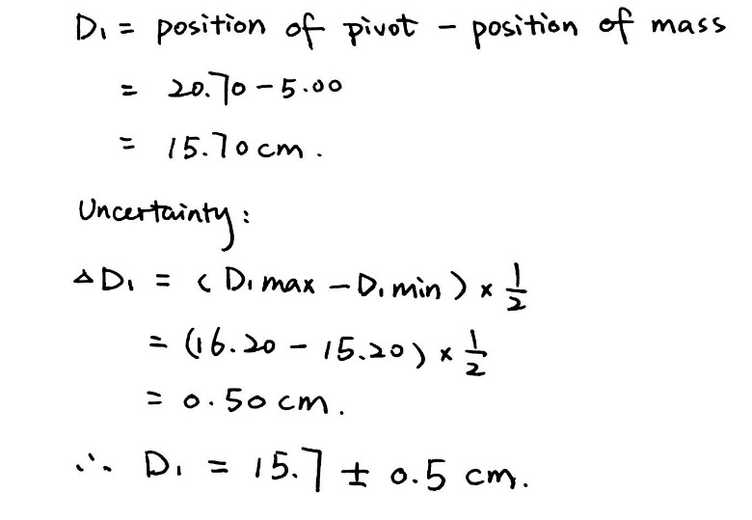
2. The arm (D2) for the weight of ruler:

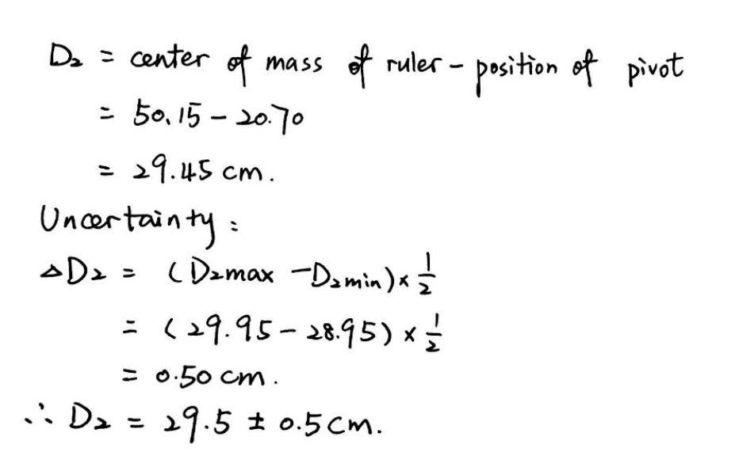

1. Using the principle of moments to find the mass of ruler:

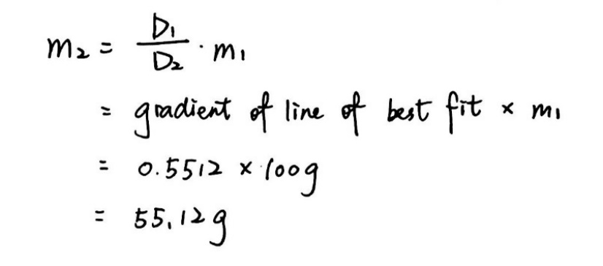

1. The uncertainty for m2 the mass of ruler:

First, to calculate the uncertainty for 55.12g, which derives from the gradient of the graph, we use the two points to graph:

|  |  |
| --- | --- |
| **D2/cm** | **D1/cm** |
| 29 | 16.2 |
| 6.4 | 3.8 |

Table 3. the data for calculating the minimum slope

Figure 3. the graph for D2 and D1 with minimum slope

And another two points for the maximum slope:

|  |  |
| --- | --- |
| **D2/cm** | **D1/cm** |
| 30 | 15.2 |
| 7.4 | 2.8 |

Table 4. the data for calculating the maximum slope

Figure 4. the graph for D2 and D1 with maximum slope

And the uncertainty for slope can be calculated by (Introductory)[1]:

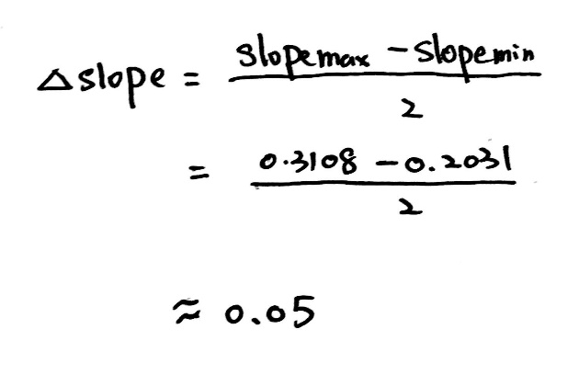

Thus, the final result is 55.12 $±$ 0.05g.

# Results and Conclusions

### Results

The result from the experiment is 55.12 $±$ 0.05g, and by using electronic scale, the theoretical value of the ruler is 55.660.01.

### cid:6cf9680a-8a69-4d27-81d7-4bb4dc458112@apcprd01.prod.exchangelabs.comDiscussion

In the experiment, a wire is vertically placed between the clip, so when reading the ruler, it will be easier to determine a more precise number. However, if we do not use that wire, the number will be hard to determine because the ruler is quite thick and it is hard to tell where the middle of the binder clip is.

Figure 3. the use of wire

Moreover, two 50g masses, which add up to 100g, are chosen to conduct the experiment. The reason for choosing 100g can be deduced by:

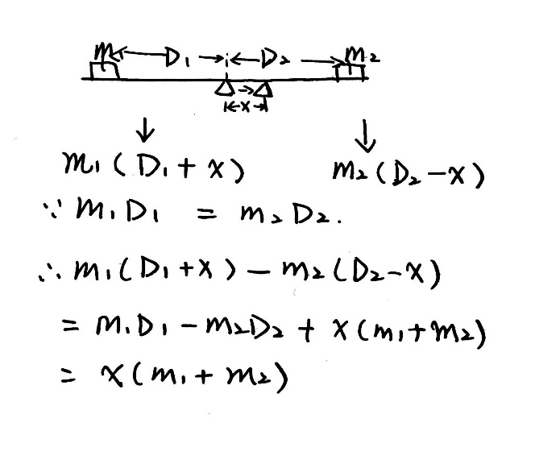

Thus, since the magnitude of the mass of ruler (seen as m2) is fixed, the larger the m1, theoretically, the more precise the measurement should be, because a slight movement (x) of the binder clip can result in huge difference between the clockwise and anticlockwise moments.

However, there is a limit to m1 and it cannot be too big, because if it gets bigger than 100g, like 150g for example, the ruler will be too hard to balance because of four reasons. First, according to x(m1+m2), a little discrepancy of the position of pivot will cause great change to the lever. Second, to get a 150g mass, three 50g masses are needed to pile up, and because the surface of the mass is relatively smooth and there is little friction between every two masses, it is hard to keep them stable, especially when the lever is slanted to one side. Third, if the mass (m1) is too large, the change of D1 might be really small that is even smaller than the smallest division of the ruler, which can be calculated by:

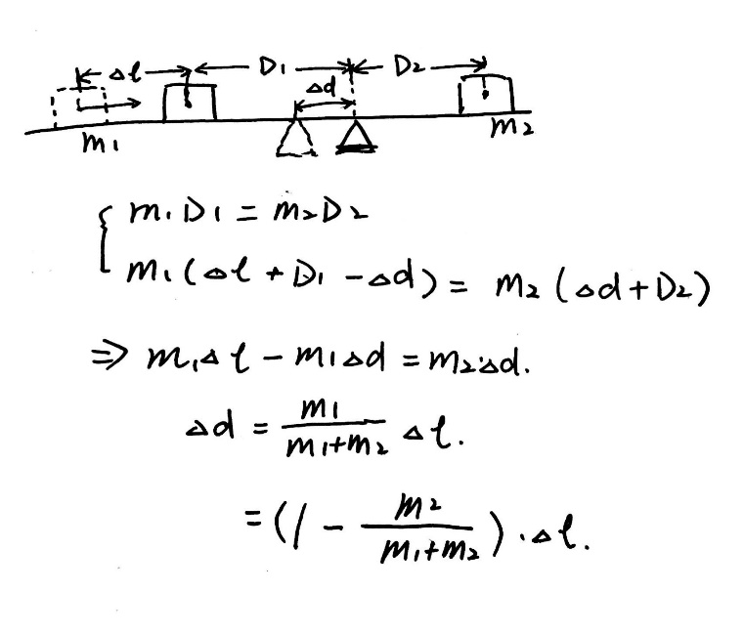

In which m2 is a constant that equals the mass of the ruler, $∆l$ is the distance mass m1 moves, and $∆d$ is the distance the pivot moves.

It means that when m1 is either too big or too small, the pivot will either get too close to the mass m1 or the center of mass of ruler, so the change of D1 or D2 will be relatively small and hard to measure.

Lastly, if mass m1 is too large, D1 will be too small that it might be even smaller than the radius of the mass so it will be difficult to read that value for it will be blocked by the mass.

Thus, if 150g of mass is used, it will be too hard to operate in a short time like this experiment.

Also, when processing the results, the gradient is used of the graph for the relationship between D1 and D2 instead of the average of all the results. That is because, by using the gradient, the y-intersect can be ignored and systematic error like parallax can be reduced, so the result will be more accurate.

Deriving from all the data collected, the final result is roughly 55.9 $±$ 0.9g. Comparing with the theoretical value 55.66 $±$ 0.01, the percent error is thus:

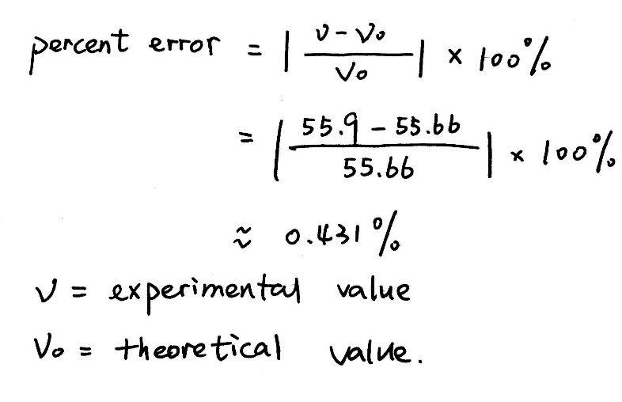

So, the result is almost consistent with the theoretical value.

However, the discrepancy may be caused by the following sources:

First, the mass is not exactly 50g each when I measured them on the electronic scale. That will give an inaccurate value of m1, and thus the result of the mass of ruler will be discrepant.

Second, the judgement of the balancing of the ruler might be wrong. Sometimes the readings of ruler may be taken before the ruler comes to rest because of the limit of time, and at that stage, the ruler may not in equilibrium, thus leading to errors in the final result.

Third, when measuring the distance, since the lever is slanted, so there might be some displacement of the masses or the pivot (the binder clip) if they are not checked frequently because the surface of the mass is quite smooth, and that can also result in errors.

Also, the position of the mass may not be exactly placed at that certain number, because the gap between the mass is wide and it is hard to determine whether the mass is placed accurately.

Lastly, the reading is done manually, so there might be some parallax error. Moreover, the reading is an approximation, and the ruler itself is not that precise with the smallest division of 0.5cm.

To improve the experiment, the following methods can be taken:

First, to know the exact value of the masses, we can first use the electronic scale to measure the masses and use those numbers to calculate the final result.

Moreover, a better pivot can be used. the height of a binder clip can sometimes be different on two sides. However, uses of something like a cone can help with that.

Also, more trials should be taken, and repeated measurement can also be used, so that the random error can be minimized.

### Conclusion

In this experiment, the aim was to determine the mass of a given ruler using the principle of moments. It is hypothesized that by changing the position of a mass, and thus adjust the position of the pivot, we will be able to calculate the mass of the ruler using the formula deduced from the principle of moments.

After performing the experiment and doing several trails, the hypothesis got confirmed. Although the measured value of the mass of the ruler differed from the actual value by less than one percent, but discrepancy exists due to different sources of error, this difference was very small, leading to the conclusion that the mass of ruler can be calculated, which is 55.9 $±$ 0.9, using the principle of moments.

1. “Introductory Physics Lab.” *Southeastern University*, www2.southeastern.edu/Academics/Faculty/rallain/plab193/page1/page35/page36/page36.html.